**Report on Project: Student Attendance Management System**

**Course Information**

**Course:**  CSE480 Web Database Programming (Sections 1)

**Instructor:**  Abdus Satter, Adjunct Faculty, CSE Dept.

**Project Name**

|  |  |
| --- | --- |
| **Title of Project** | Student Attendance Management System |
| **Student**  **(ID & Name)** | Abdullah Muhammad Tahir (2017-1-60-082) |

**Project Purpose**

The purpose of the project 'Student Attendance Management System' is to make a sound attendance system for online classes or courses. As we can see in today's world, there are various platforms for taking or participating in online courses. Most of these platforms do not include a sound attendance system for the participants in different classes and also do not have a convenient attendance management system for the teachers or the course instructors. The emergence of such a structure can help improve the students' participation and lessen the course instructors' inconvenience. In addition to these, the system can be an alternative to the traditional one as the conventional attendance management system requires a massive amount of time and effort to manage documents and calculate data.

**Project Goals and Objectives**

The goals and objectives of the Student Attendance Management System are as follows:

1. To provide an easy, fast, and reliable system that can be used in both online platforms and an alternative to the traditional attendance management system.
2. To create a system where a teacher with a few clicks can generate attendance reports (daily, weekly, monthly) of individual students.
3. To create a trouble-free platform where students can submit their daily attendance on their own and save both student’s and teacher’s time.
4. To set up not only an attendance management system but also to provide an idea of integration of the system in online course management.
5. To allow the update, delete, or adding information (courses, students, and teachers) by a super admin when needed.

**Project Description**

The developed system is the ‘Student Attendance Management System.’ This web application is based on a database that can be used in platforms for online classes or as an alternative to the traditional ‘Call and Response’ attendance management system. The attendance records of the students are saved in a database. Teachers can generate reports of individual students to determine their attendance scores. A teacher can create attendance reports for an individual student by setting duration daily, weekly, or monthly for individual courses. It helps teachers save their time using an automated system as they do not need to find documents for each student and determine attendance scores. Students are also able to generate their attendance reports for their enrolled courses. In short, this is an efficient system to keep an attendance record for a massive number of students and a more comfortable, faster system for calculation related to attendance scores. This web-based application also includes a course management system that provides an idea of how an attendance management system can be included in existing online academies.

**Scope**

The developed system is mainly focused on student attendance management, where students can submit their attendance for their courses according to routine, and the teacher can generate his/her student’s attendance records. With more work and effort, the system can be upgraded to a student management system for an academy or educational institution, or the attendance management system can be integrated into the existing student management systems. It can also be modified into an employee attendance management system, which can be very helpful for corporate companies.

**System Users**

* **Administrators:** Administrators have full control over the web application. An administrator can add courses to the system, assign teachers to courses, and delete courses from the system. Also, he/she can edit the students' and teachers' necessary information.
* **Students:** After an authenticated login, students will have the privilege of functionalities like generating their attendance report, submitting attendance for courses, requesting dropping a course, etc.
* **Teachers:** After an authenticated login, teachers will be able to manage assigned courses. He/she can generate attendance reports for individual students in his/her courses (Daily, weekly, and monthly).

**Database**

The Entity Relationship Diagram of the Database of the project Student Attendance Management System:

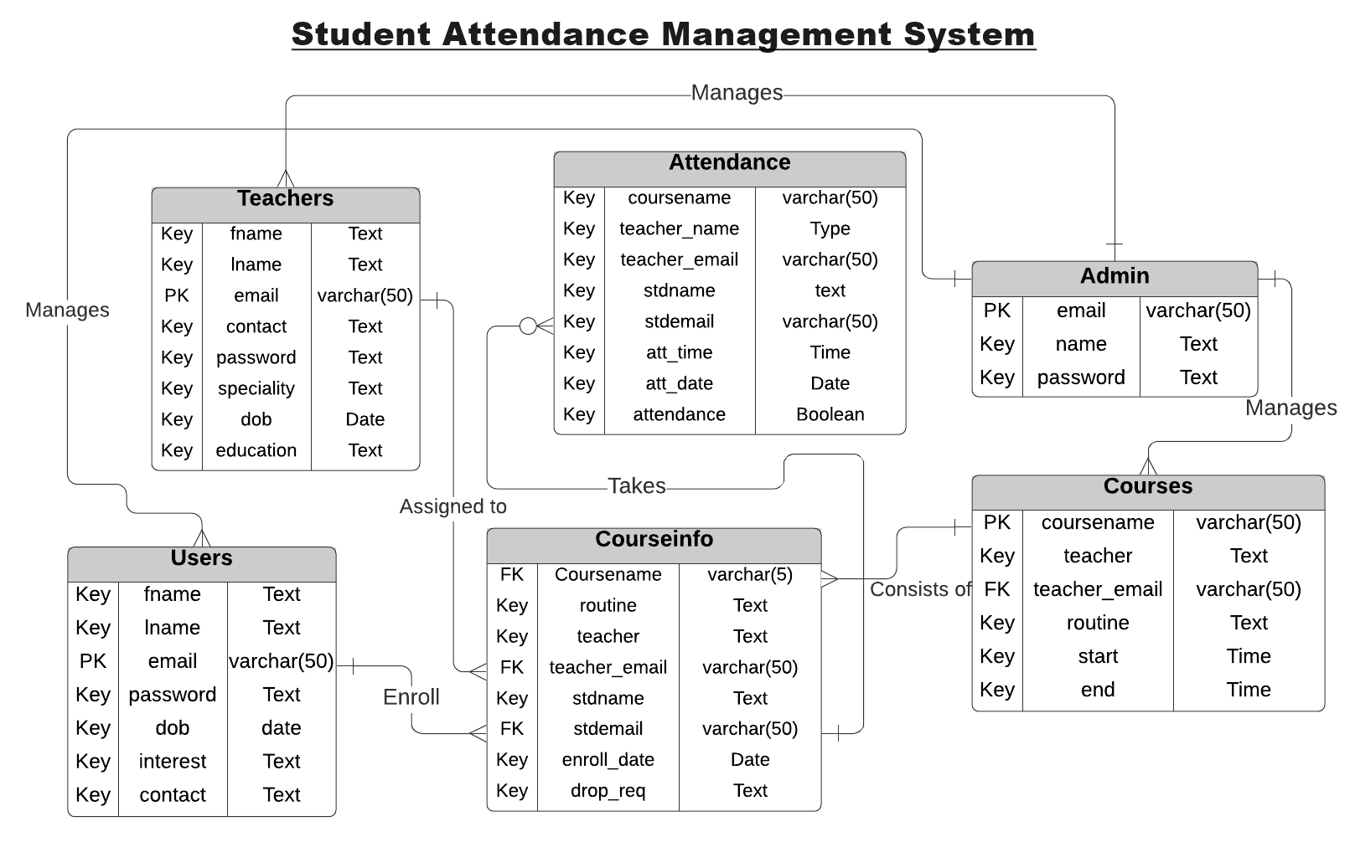

**Processes**

* **Login:** All system users (Administrators, Students, and Teachers) have to go through authorization before accessing the functionalities. Using email and a unique password, a user can sign in to his/her account, and if the provided email or password do not match with the one s/he has provided during signing up, s/he will not be able to sign in and will be notified with an error message.

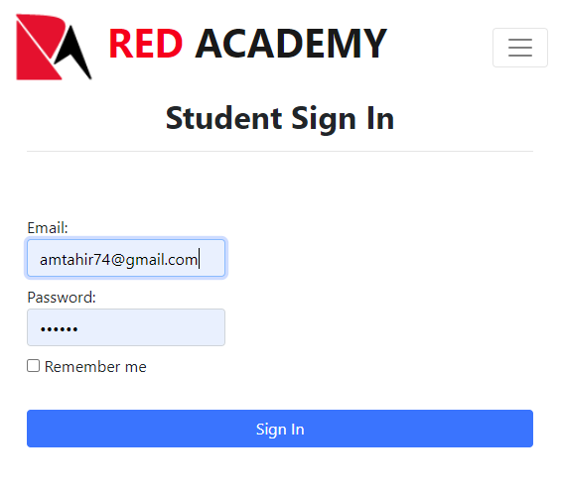

Figure 1 Sign in Example Screenshot (Student)

* **Registration/ Sign Up:** Visitors can sign up as a student or teacher. There is no sign up option for administrator. The email Id is unique field. The system cannot take an email id more than once. The screenshot is given on the next page

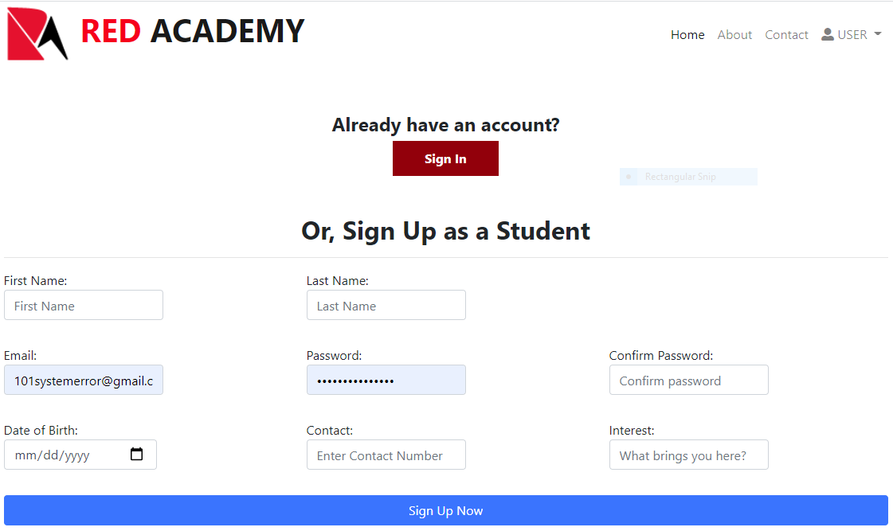

Figure 2 Sign Up Example (Student)

* **System Management (By Admin):** An admin can add courses to the system by providing unique course code, a routine for the course and class duration.

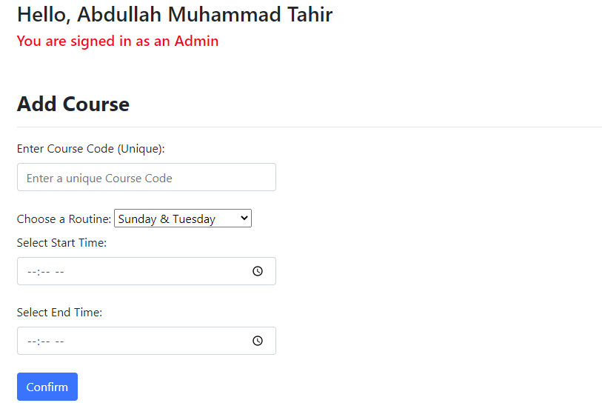

Figure 3 Add Course from Admin Account

Then s/he is able to assign teachers to the newly added courses.

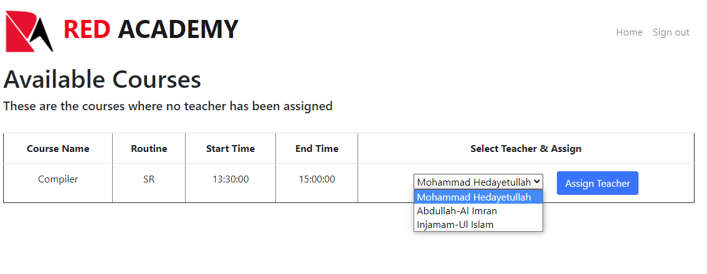

Figure 4 Assigning Teacher to a newly added Course

Not only adding course, administrators are also privileged with the ability of deleting a certain course from the system, if needed.

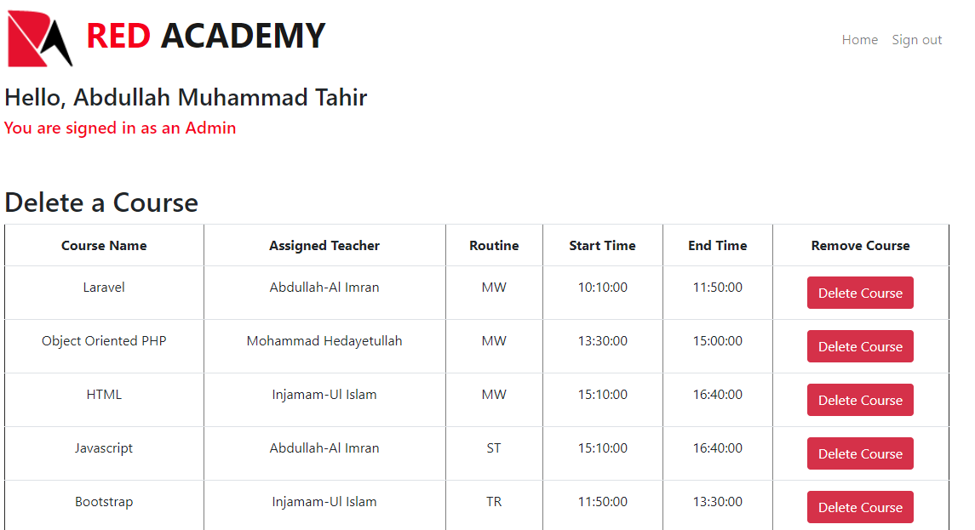

Figure 5 Deleting a Course from the system

Administrators are also able to edit student or teacher’s basic information if needed. Also, they can drop courses for students if requested.

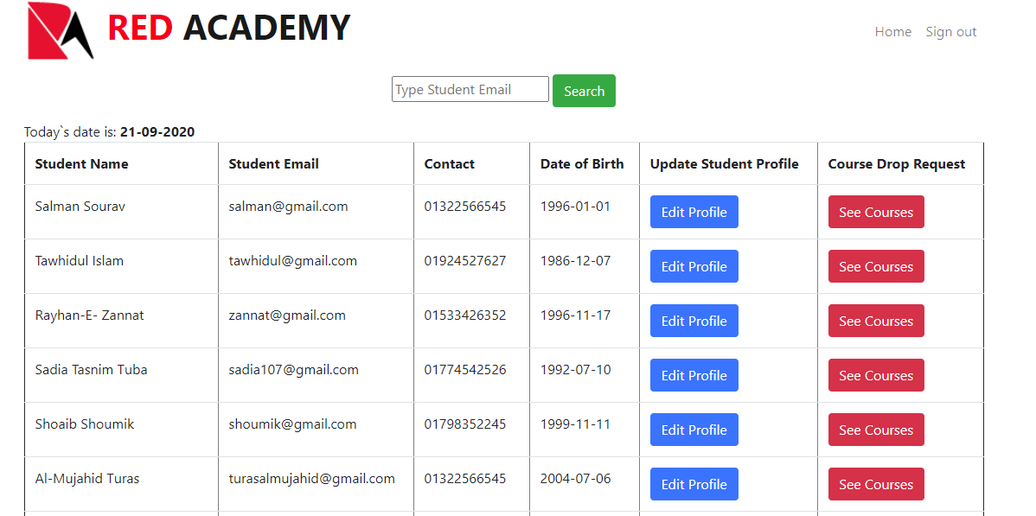

Figure 6 Edit Student Profile and See Course Drop Request

* **Course and Attendance Management (By Student):** After signing in to a student account successfully, a user can submit attendance for an enrolled course within an allowed time (Scheduled Class-time). If the time is over, s/he cannot submit attendance for that course on that day.

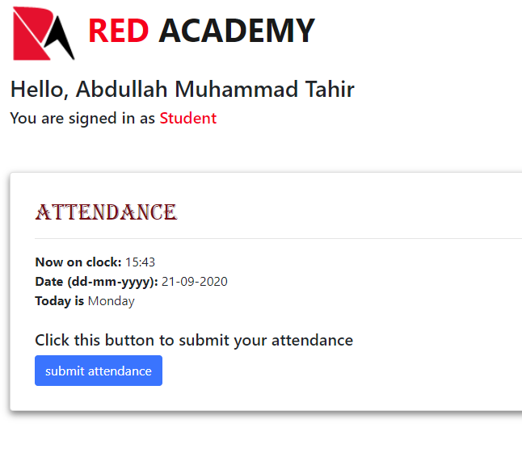

Figure 7 Submitting Attendance

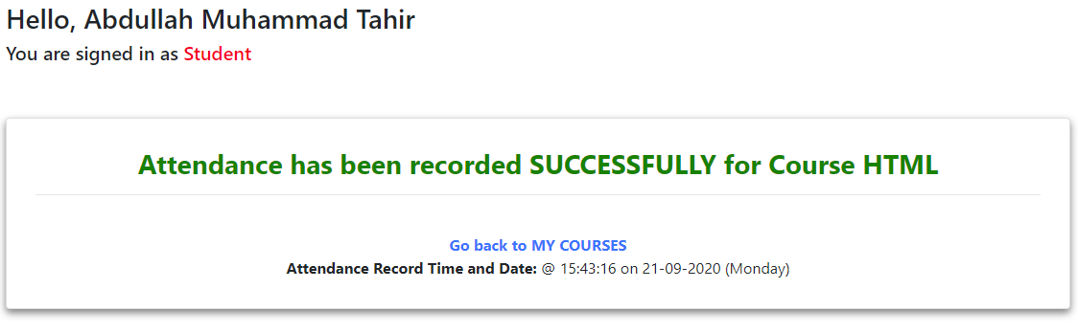

Figure 8 Attendance Submission Successful Message

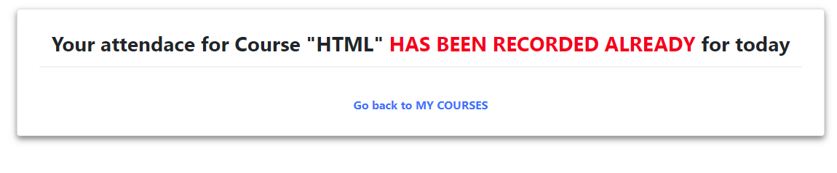

Figure 9 Attendance cannot be submitted more than once!

Students can generate their own attendance report from their account by setting a duration. However, they cannot set the start date which is before the day of enrollment of their first course. The report is generated as pdf.

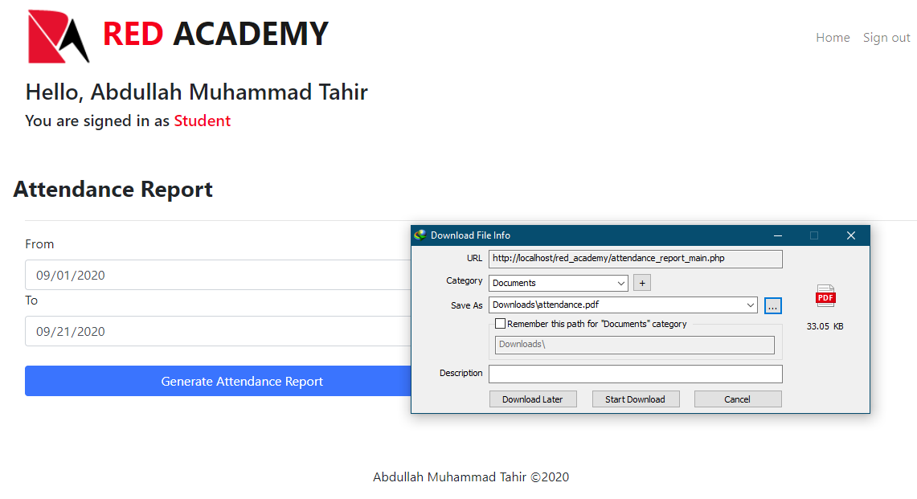

Figure 10 Attendance Report from Student Account

Students can enroll in new courses. The course must be available and must be assigned to a teacher.

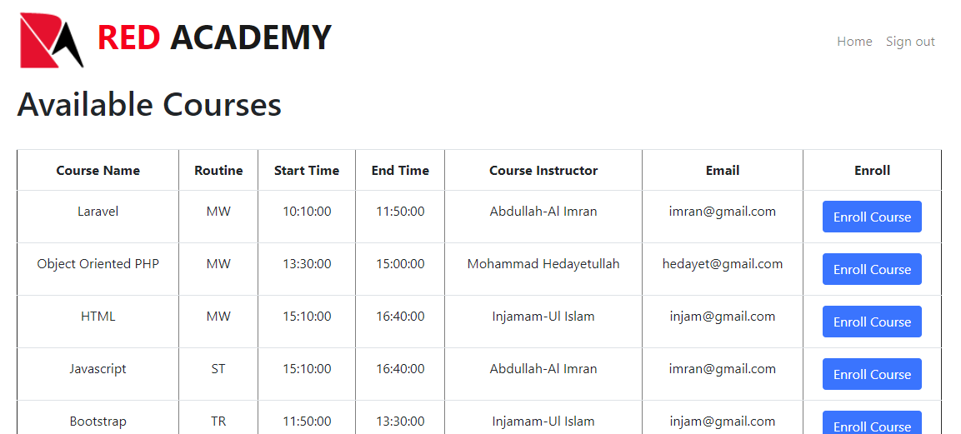

Figure 11 Enroll new courses (Student account)

Students can request to the admin for dropping a course.

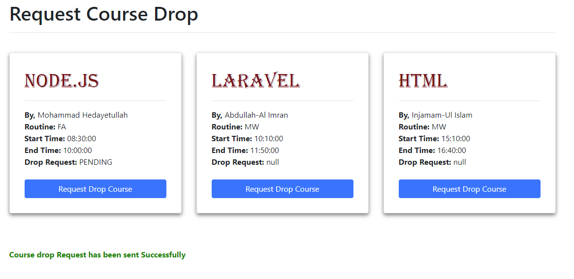

Figure 12 Request Course Drop From Student Account

* Course and Attendance Management (By Teacher): After a successful log in a teacher can enter in one of the assigned courses and generate attendance reports of individual students of that course by setting the time duration.

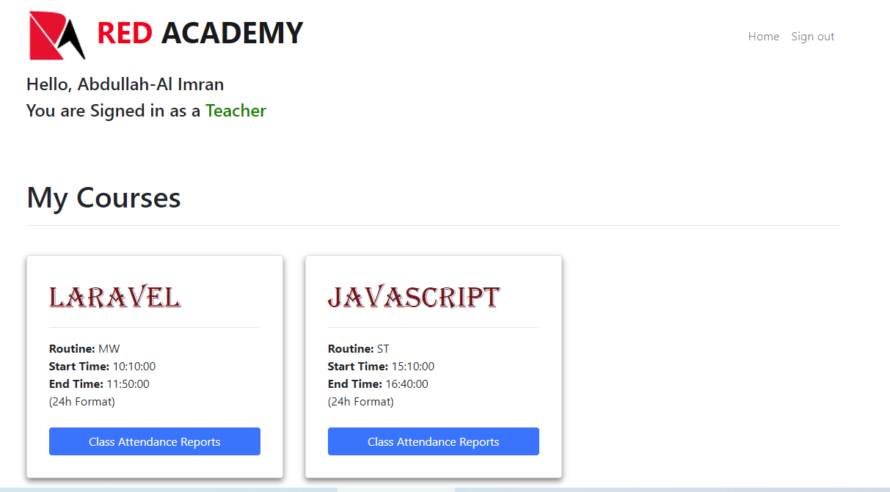

Figure 13 Show assigned courses in teacher's homepage

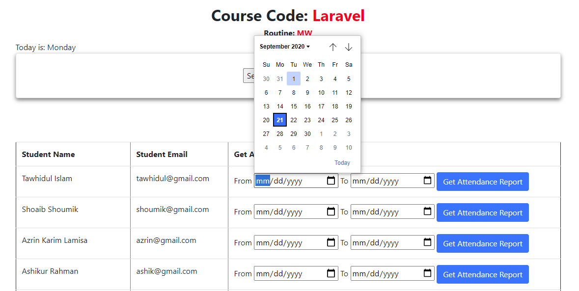

Figure 14 Setting duration to generate the attendance report of a student

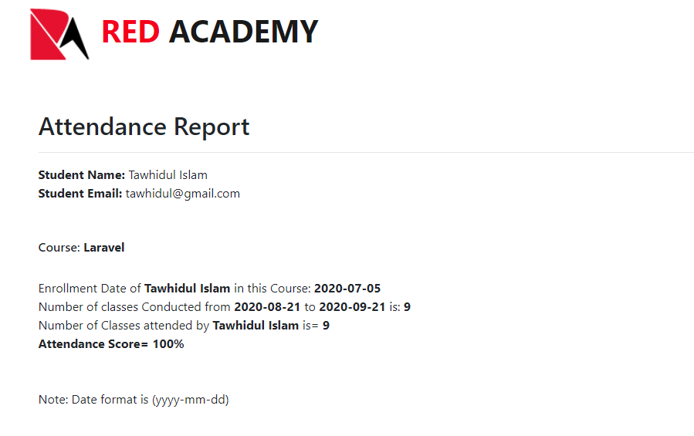

Figure 15 Attendance report of a student between input dates

A teacher can also see attendance record of that day if any of his/her courses has class on that day.

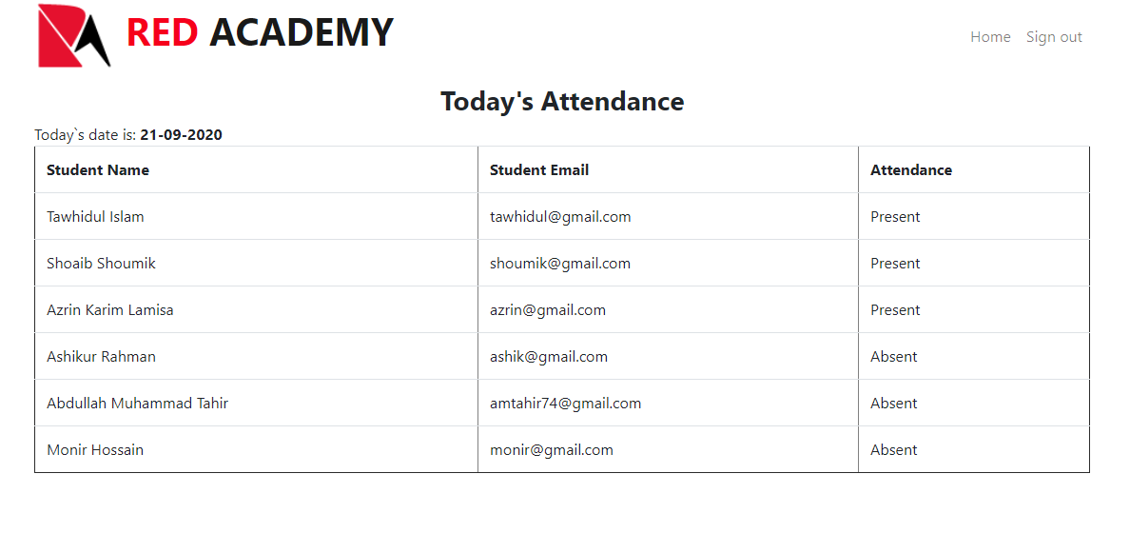

Figure 16 Today's Attendance

**Technology**

**Frontend Language:** HTML, CSS, Bootstrap, JavaScript.

**Backend Language:** PHP**,** MySQL Database (Using phpmyadmin).

**Text Editor Program:** Atom.

**Operating System:** Windows 10 (x64).

**Localhost by:** xampp